# **Docker & Docker Hub**

**Assignment 1:**

Demonstrate minimum 15 basic docker command with explanation and screenshot**.**

1. **docker images** :- Command is used to list all the docker images available locally in your system.

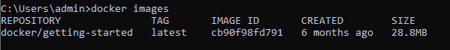

1. **docker run -d -p 80:80 docker/getting-started :-** The docker run command creates running containers from images and can run commands inside them.



1. **docker run –it** :- It will run container in interactive mode.

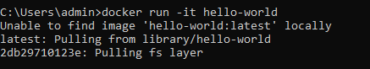

1. **docker ps** :- The **docker ps** command is used to show you the running containers on your current Docker host.



1. **docker info** :- This command displays system wide information regarding the Docker installation.

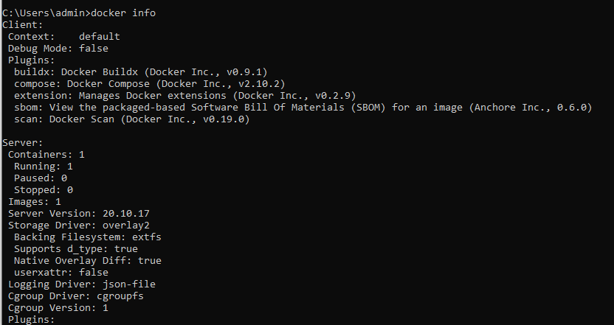

1. **docker ps –a** : - It shows list of stopped container

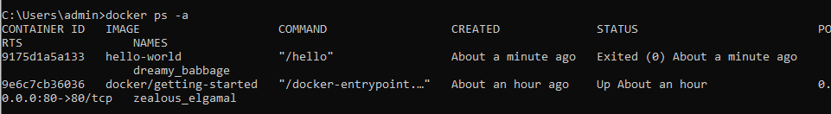

1. **docker build –t welcome-app .** :- The build command is used to build an image from a Dockerfile, but the command has to be run in the same directory as the Dockerfile.

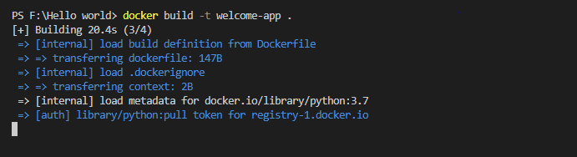

1. **docker rm “container id”** :- this command used to delete Stop container



1. **docker stop :-** Stop the running container



1. **docker rmi “image name ”** :- used to remove image



1. **docker push :-** It helps to push docker image to docker Hub

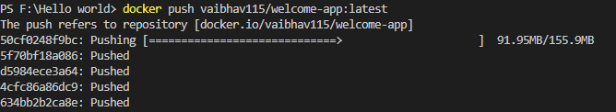

1. **docker tag:-** it convey useful information about specific image version

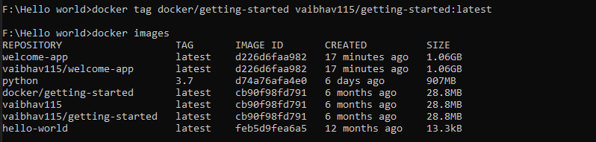

1. **docker attach “container id”:-** it is used to attach local standard input output and error strings to running container
2. **docker create “image name”:-** It is used to create a new container using a docker image

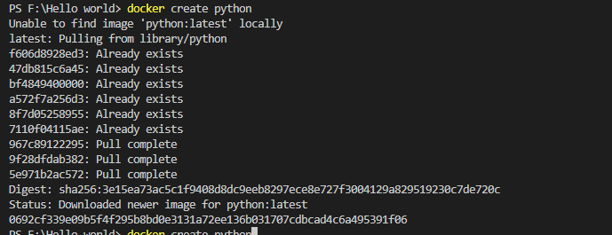

1. **docker start ”container id ”** :- used to start created container



### Docker top ”container id”:- is used to list process running in docker container

### 

### Assignment 2:

[Hello World Docker Image](https://hub.docker.com/_/hello-world) Run Hello World Docker Image Locally.

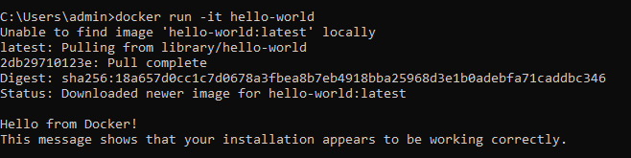

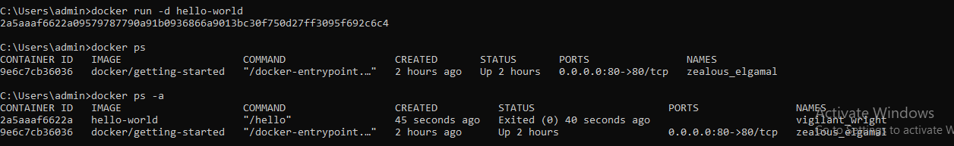

### Assignment 3:

Create a hello world fastapi application. Create a Dockerfile for your fastapi hello world application. Build Docker image using Docker file. Run docker image build in previous step. Push your Docker image to Docker Hub.

### 

### 

### 

### 

### Assignment 4:

Automate Assignment below task using github action.

1. Build Docker Image
2. Push Docker Image to Docker hub.